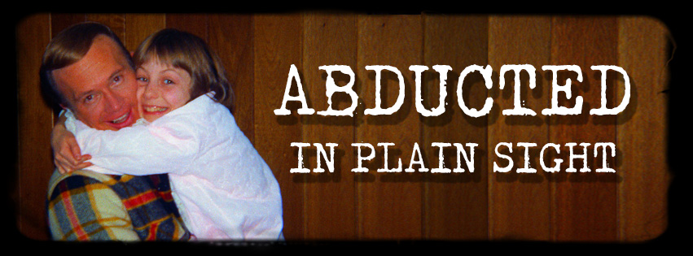

Top Knot Films presents:

ABDUCTED IN PLAIN SIGHT
A film by Skye Borgman

91 MIN / U.S.A. / Color / 2018 /

Website:
www.Abducteddoc.com

Facebook
https://www.facebook.com/abducteddoc/
https://www.facebook.com/topknotfilms/

Twitter
https://twitter.com/abducteddoc

Instagram
https://www.instagram.com/abducteddoc/

Contact:
Skye Borgman Stephanie Tobey Emily Kincaid
323.309.2766 424.901.9385 347.861.5256
skye@topknotfilms.com Steph@stephanietobey.com emilykincaid17@gmail.com

Sales Contact:
Amanda Lebow/CAA
424.288.2000
Amanda.lebow@caa.com

“ABDUCTED IN PLAIN SIGHT” is a true crime documentary that tells the twisting, turning story of the Broberg’s, a naïve, church going Idaho family that fall under the spell of a sociopathic neighbor who will stop at nothing to be with their 12 year old daughter.
Synopsis:

On October 17, 1974, in the tight-knit town of Pocatello, Idaho, 12-year-old Jan Broberg begged her parents to go horseback riding with the neighbor down the street. Robert Berchtold (whom the Broberg’s affectionately called ‘B’) was married, father of five children, the family’s dearest friend, and devoted LDS Church member. He picked Jan up from her piano lesson at 3:45 pm to take her to the stables.
They never made it to the stables. Jan was kidnapped, drugged, and strapped to a tiny bed in the back of a motorhome bound for Mexico. Upon awakening, Jan heard high-pitched voices repeating unbelievable commands through a small intercom next to her pillow. The voices told her that she had been chosen to save a remote planet by bearing a special child, fathered by Berchtold, before her 16th birthday. If she did not cooperate, she would be "vaporized" and her family would be murdered.
Jan’s parents, Bob and Mary Ann Broberg, waited 5 days before calling authorities. The FBI conducted a nationwide manhunt and five weeks later, Mexican police storm a motorhome outside of Mazatlan and take Berchtold into custody and the Broberg’s took Jan home.
Jan’s refusal to talk about the events in Mexico and her parents’ decision to draft an affidavit, absolving Berchtold of the crime, resulted in an unbelievably light sentence. Berchtold served only 10 days in jail and was soon back in his home, a few doors away from Jan’s house, where the brainwashing and sexual abuse continued.
In April 1976, Jan disappeared a second time. This time Mary Ann and Bob waited two weeks to call the FBI, giving Berchtold time to enroll Jan in an all girls Catholic School in California. Impersonating a CIA agent, Berchtold convinced the Nuns that Jan was his daughter and needed protection from persons seeking to kidnap her and possibly take her life. Five months later, the FBI located Jan at the boarding school, under an assumed name.
It took Jan 4 years to reveal details of her double abduction. When she was 16 years old, Jan told her family about the kidnapping and brainwashing. Jan was 21 years old before she revealed that Berchtold had repeatedly raped her from the time she was 12 until she was 15. Jan was well into her 40’s when Berchtold took his own life – after threatening Jan and her family at a conference where Jan was speaking.
“ADBUCTED IN PLAIN SIGHT” tells the story of one family’s struggle with desire, deceit, faith and forgiveness. The Broberg’s troubling admissions reveal epic failures and untold personal dramas that point to the biggest tragedy of all – that these crimes could have been prevented.

Who is in the film

Jan Broberg was a charismatic young girl. The oldest of 3 sisters, Jan was their champion. She was fearless, bright, and eager and she had her whole future ahead of her. Jan was kidnapped when she was twelve years old and again when she was fourteen. She was brainwashed, drugged and sexually abused by her parents’ closest friend and neighbor, Robert Berchtold for 4 years.

Mary Ann & Bob Broberg raised a devoted family with LDS values. Bob was a business owner, building his flower shop into a flourishing career while MaryAnn was responsible for the care of their children and home. They were trusting and naïve, an easy target for their new “best friend” Berchtold.

Susan Broberg and Karen Campbell. Jan’s sisters are loving and compassionate. They deal with the kidnapping of Jan in different ways. Susan – The youngest of the 3 hides away and doesn’t want to know anything, while Karen listens behind closed doors, asks questions and wants to know everything that is going on. Both women carry scars from their families ordeal in the 1970’s into their present day families.

Robert Berchtold was an energetic father of five, a loving husband, a pillar of the community. He became best friends with Mary Ann and Bob Broberg and their families quickly became inseparable. Berchtold did things with the Broberg’s that they couldn’t afford on their own such as horseback riding, boating trips and summer vacations. He cared for Jan and her sisters as if they were his own children. But, Berchtold’s motives were sinister. He was meticulously plotting to kidnap, brainwash and sexually assault Jan.
Pete Welsh. FBI special agent in charge. The Broberg/Berchtold case was Pete’s first ever pedophile investigation. The FBI had been championing Stranger Danger and the idea that most kidnappings were and would be committed by someone that the child knew was a distant reality. This bizarre case shaped Pete’s career and gave the FBI valuable information that their ideas of Stranger Danger were far from accurate.

“ABDUCTED IN PLAIN SIGHT”
Crew Bios

Skye Borgman – Director/Producer/Cinematographer
Skye Borgman is an award-winning director and cinematographer who films narrative and documentary films all over the world. She has shot over 50 films, traveled to over 60 countries and lived on three continents. Her global experiences guide her vision, thought and approach to film-making. This gives her the unique ability to connect with all types of personalities. She has filmed rock-stars, prime ministers, drug addicts, environmentalists, Academy award winners, Buddhist nuns and anarchist chocolate makers. With a keen sense of adventure, Skye brings excitement to everything that she films. Her fusion of lighting, collaboration, and absolute fearlessness gives her filmmaking an evocative, honest and approachable style.

Skye's latest NETFLIX documentary, ABDUCTED IN PLAIN SIGHT has captivated the world, with people boasting “it’s the craziest documentary I’ve ever seen.” With write ups in Vanity Fair, Rolling Stone, Vice, Newsweek, The Vulture and Marie Claire (to name a few) the film redefines the true crime genre and delves deep into the human condition.

Skye is the co-owner of Top Knot films, an award winning production company
creating extraordinary film, television, documentary and new media content. Committed to delivering captivating projects with such emotional impact that they challenge, amaze and inspire us to celebrate our everyday lives.

Stephanie Tobey – Producer
Stephanie Tobey is a Los Angeles based actress and producer. Producing credits include the feature horror/comedy, “Killer Party”, which has world-wide distribution and was the recipient of numerous awards, including Best Horror Feature. She produced the short film “The Games” and co-produced the comedy web-series “Dog Park”. As an actress, Stephanie can be seen on the TBS hit series, “Cougar Town”, as well as in “Killer Party” and the haunting web-series “Prove It”. She also works closely with the LA County Sheriff’s Department, as an actress for their Homicide School and Interrogation Training Program.

Emily Kincaid - Producer
Emily Kincaid is an Actress/Producer living in Los Angeles. Emily recently produced a Film-Noir inspired film called 'Black, White, Read'. With a background in Social Media and Public Relations, she works freelance with Disney and Andre Balazs Properties, as well as various TV programs including The Today Show, Inside Edition and KTLA. Frequently seen on Lifetime, Emily has worked with notable directors Eli Roth, Jonathan Goldstein, and John Hillcoat. She has filmed two music videos with the artists, Massive Attack and Bob Dylan. Proficient in comedy and improvisation, Emily played a supporting role in the slapstick comedy 'Gender Bender' and is filming a project for Adaptive Studios. Emily is represented theatrically by Industry Entertainment.

James Cude – Editor
James Cude is an award-winning editor with over 15 years of experience and has edited projects in 3 different languages (English, Spanish and ASL). Feature credits include “No Ordinary Hero” starring Academy Award winner Marlee Matlin, “I Do”, "Undocumented," and the award-winning doc “Pageant." James received a 2015 Daytime Emmy nomination as lead editor for “Got Your 6” (MTV). Television projects include “Tornado Alley”(Weather Channel), “Reunion” (HBO), “Booze Traveler” (Travel), “Haunted Highway” (SyFy), “Auction Kings” (Discovery),“Crime 360” (A&E) and more! Outside of the edit bay, in 2008, James qualified for the U.S.A. National Deaf Team. He competed in the Deaflympics in Taiwan, and has the distinction of being the oldest American ever to compete in that sport at the Deaflympics.

Carl Dante– Composer
Carl Dante's talents as a composer, orchestrator and songwriter, make him an ideal choice
for any project seeking a strong, original musical statement. He is internationally known
for his film scores and songwriting, ranging from the light-heartedness of his European
"Sesame Street" work, to the ambient score of Paramount's "Indiana Jones" satire,
"Cannibal Women in the Avocado Jungle of Death" (Starring Bill Maher, Barry Primus and
Shannon Tweed).
In 1975, Carl established his own company, "Intamusic Publishing/Films"; and in 1979,
"Music Connection" magazine hailed Carl as one of the best, new "underground" artists.
In the 90's, Carl completed a sound engineering degree while simultaneously composing
the new 1992 (and 1996) Olympic Themes for EMI worldwide, along with several films
for cable television. The Hollywood Reporter selected him as one of nine "unknown"
composers they believe are at the top of their field.
Still persistently prolific, Carl Dante promises to leave an indelible musical mark with
such an enduring career. He's an artist of stature who brings taste and professionalism
to any project with which he is involved.

Skye Borgman sits down for an interview with
Julie Miller from Vanity Fair
-February 14, 2019

Abducted in Plain Sight: Even More Shocking Details About Jan Broberg’s Kidnapping

Filmmaker Skye Borgman opens up about the unbelievable twists and turns of the Jan Broberg kidnapping case, Robert Berchtold’s commitment to his crime, and the crazy details she had to cut from her buzzy documentary.

Abducted in Plain Sight filmmaker Skye Borgman understands why audiences might want to scream at their televisions while streaming her true-crime documentary. The 91-minute film, originally released in 2017, has captivated an entirely new audience since premiering on Netflix this month. It chronicles the peculiar kidnapping case of Jan Broberg, an Idaho teenager who was abducted by her decades-older neighbor Robert Berchtold in the 1970s. But Berchtold—known as “B”—did not just kidnap Broberg once; he entrapped Jan’s religious parents in such a web of trust, shame, and complicity that he managed to convince the family to drop the most serious kidnapping charges against him, continue letting him spend disturbing amounts of time with their young daughter, and—in the most shocking twist of all—he eventually kidnapped her a second time.
“It is incredibly challenging to understand why and how these people went through this, but that’s part of the story,”explained Borgman to Vanity Fair, before admitting that even she became so incensed that she eventually had to take a break during the editing process.
“We spent so much time with them on the computer, going through what they had said, and [editing] things together,” Borgman continued. “There were times when the family was just so frustrating to me.” At one point, Borgman and her editor hit pause on the project for a solid six weeks. “It was the best thing that we could’ve done, because we were able to come back and feel everything we were supposed to feel,” she said.
It is important to remember that Jan’s kidnappings took place in a small town, decades before the Internet and true-crime television franchises turned Americans into armchair experts on such seedy subjects as pedophilia, Stockholm syndrome, and grooming. Borgman explained that the Broberg family’s faith, as members of the Church of Jesus Christ of Latter-day Saints, also gave them an extraordinary capacity for forgiveness—a subject Borgman would like to explore if she is able to pull together funding for a sequel to Abducted in Plain Sight.
Until then, Borgman shared even more shocking revelations about the Broberg family; Robert Berchtold’s alien-abduction grooming technique; and the effects the kidnapping has had on Jan as an adult.
This documentary was the first time Jan’s father, Bob, publicly confessed to having his own romantic entanglement with his daughter’s kidnapper.
Borgman first learned of Jan’s kidnapping through Stolen Innocence, a memoir Jan wrote with her mother, Mary Ann. But the first edition of the book left out several very pertinent details, such as the affairs both Jan’s mother and father had with Berchtold.
During the preliminary discussions the filmmaker had with Jan, Jan was “pretty forthcoming” about the affair her mother had with Berchtold. But the filmmaker didn’t know about Bob’s own “indiscretion” until she got ahold of F.B.I. documents and court transcripts.
“When we were going into the interview, I really wasn’t sure if I was going to ask him about it,” said Borgman, explaining that Bob volunteered details about the sexual act he performed on Berchtold. “I think Bob realized that it was a critical element to the story, and how [Berchtold] was able to get into their family this way so seamlessly,” said Borgman.
The “indiscretions” will be detailed in a new edition of the Brobergs’ memoir now that, according to Borgman, the family “really understand[s] the importance of how those two instances led to [Jan’s parents’] denial” of Berchtold’s relationship with Jan. Borgman explained that both Bob and Mary Ann were “so consumed with their own actions and their own trauma that they just didn’t pay attention [to their daughter’s relationship with Berchtold] the way that they were supposed to.”
Berchtold allegedly used his convoluted “alien-abduction” grooming narrative on multiple victims.
One jaw-dropping twist in Abducted in Plain Sight occurs during the first kidnapping, when Jan says that Berchtold used a cassette player to trick her—just 12 years old at the time—into believing that she had been kidnapped by aliens and that she could save her family only if she accepted a secret mission to procreate with Berchtold. During Vanity Fair’s conversation with Borgman, the filmmaker confessed that she initially had a hard time believing this element to Jan’s story.
“I constantly questioned if this had really happened,” said Borgman. “If this little box was next to Jan and if these alien voices were really playing through. I got to one point where I was like, ‘Well, maybe it doesn’t matter if it’s real. Maybe this is what Jan has had to tell herself to cope with the situation and get through it.’”
“Then, while we were working on the film, one of Berchtold’s other alleged victims reached out to us and told us a story about him using this alien psychology and saying, ‘You’re a princess from a different planet.’ He used this whole alien story on her, and that was the moment for me when I thought, ‘Oh my gosh, it’s real. He did it.’” (Neither this accuser nor the other alleged Berchtold victims that came forward wanted to revisit their ordeal on camera.)
Asked how Berchtold came up with this extravagant deception plan, Borgman said her only theory is that inspiration struck from the 70s zeitgeist. “This whole idea of science fiction was popular, and tape recorders had just come out. There were also a lot of newspaper articles about U.F.O.s and whether or not they were real.”
Even though Berchtold’s brother Joe was aware of his brother’s inappropriate behavior, he felt the need to participate in the documentary on Berchtold’s behalf.
Borgman interviewed multiple members of Jan’s family, but when it came time to reach out to Berchtold’s immediate family members—who lived next door to Jan’s family growing up—“nobody really wanted to do an interview.” Explained the filmmaker, “They weren’t interested in dredging up the past.”
Because Berchtold committed suicide in 2005—after coming face-to-face with Jan in a courtroom, a bizarre meeting included in the documentary—and is not able to defend himself, Berchtold’s brother Joe felt the need to participate in Borgman’s film.
“I don’t know that he trusted us completely, but he wanted to give his brother a voice,” said Borgman. “It’s something I think about a lot—that sibling love and how strong that is. I think that comes out a lot with Joe, that he loves his brother, even though his brother was a pedophile, and I think those two things really are conflicts in him. He still loved his brother.”
Some crazy details were left on the cutting-room floor.
To streamline the documentary, Borgman ended up leaving out several story elements—including a meet-up that Mary Ann had with Berchtold in a parking lot, allegedly involving a gun and Mary Ann’s brother. Borgman also consulted with a forensic psychologist, providing her with court transcripts and other evidence of Berchtold’s fixation with Jan to help her get a professional read on “B.”
“She explained how much work it takes to actually kidnap somebody,” Borgman said. “That’s why it doesn’t happen more often, because there’s so much planning involved, and there’s so much deceit that goes into it. To be able to actually kidnap somebody is incredibly difficult. Then to be able to maintain this ruse for years and years really takes somebody who has very little empathy for anybody else. It really does take a sociopath.”
Borgman is hopeful that she can one day make a sequel to this film, “to explore the different topics that we didn’t have time to really dive deep into, like the role that faith plays—maybe not even just L.D.S.—but the role that faith plays in sheltering communities,” said the filmmaker. “Also grooming and brainwashing—there are really interesting, intricate things that happen, and we touch on both of those topics in the documentary, but I’d love to explore those more. I guess in a perfect world, it’d be sort of a trilogy of films.”
Jan still sees Berchtold as her benchmark for love.
After her trauma, Jan went on to get married, have a son, and get divorced. As Borgman explained, Jan’s relationship with Berchtold, understandably, had lasting effects on her adult life. “It had a huge, huge impact on her relationship with men,” said the filmmaker. “I remember talking to her at one point, and she said that she still looks at her relationships, and she’s never felt as in love with any of the men that she’s been in relationships with as the kind of love she felt with Berchtold. That speaks huge volumes to how impressionable children are—12-year-old kids, especially. To this day, Jan struggles with how to love and how not to associate that love with the love she felt for Berchtold when she was 12 and 13 years old.”
Bob and Mary Ann stayed married until Bob’s death in 2018.
In spite of the trauma of the kidnapping, and the separate “indiscretions” husband and wife had with their daughter’s kidnapper, Bob and Mary Ann stayed married until Bob died last November. Asked whether Bob’s affair with Berchtold continued beyond the car incident, Broberg said she isn’t sure.
“We certainly couldn’t find any indication that it continued,” said Borgman. “It has been a question that a lot of people have asked or posed, and I also find it curious. I’m not sure that it matters if there was or if there wasn’t, because it was this one indiscretion that really gave Berchtold the ammunition he needed to blackmail the head of the household. One time or more than that, the deed was done, and the ramifications of that were set in motion.”
Jan is now a working actress who has appeared on over 30 episodes of the WB series Everwood.
Jan has gone on to have a successful acting career, appearing in more than 45 film and television projects according to her IMDb page. “She still auditions, but she started running a theater company in Utah and it’s been wonderful for her,” explained Borgman. “The press that she’s getting has been a lot, but she’s doing really well. . . . She says that you can choose how to live your life. 90 percent of her life is amazing and wonderful, and 10 percent is not, and she chooses to live in the 90 percent. I do give her a lot of respect and a lot of props for doing this documentary and for telling this story, because it's easy to let that 10 percent creep back in. She just doesn't allow that to happen.”
It has, however, been hard for Jan—and her siblings—to see their parents criticized in response to the documentary. After the film premiered, however, Jan’s father Bob approached the filmmaker with genuine appreciation. “Bob said that he was just so grateful that we had told their story in such a sensitive way,” said the filmmaker. “It was really quite shocking to me and, I think, speaks more to the Brobergs’ capacity for truth and forgiveness and just wanting to get that story out there.”
Now, in the Internet Age especially, Borgman and the Brobergs want to make audiences “aware of how people can enter our lives, and we need to protect our children a little bit more . . . I think that’s something that Jan and her sisters have all been advocates for—getting the word out there that it can happen to somebody close to you, by somebody you know. Don’t trust everybody. Don’t trust anybody, almost.”
GET VANITY FAIR’S HWD NEWSLETTER

“ABDUCTED IN PLAIN SIGHT”
CREDITS:

Director, Producer, Cinematographer
Skye Borgman

Producer
Stephanie Tobey

Producer
Emily Kincaid

Editor
James Cude

Composer
Carl Dante

Featuring:
(In order of appearance)
Bob Broberg
Karen Campbell
Jan Broberg
Susan Broberg
Mary Ann Broberg
Pete Welsh
Joe Berchtold
Cornelius A. Hofman

Additional Interviews:
Annette E. Belnap
Diana Concannon
Paula S. Fass
Danielle Holjeson
Caroline Pearson

Dramatization Cast

Jan Broberg Lainee Rhodes
Sinclair Dumont

Robert Berchtold Devin Ordoyne

Mary Ann Broberg Jill K. Turner
Sara Caldart Olson

Bob Broberg David McIntyre

Gail Berchtold Emily Kincaid

Karen Broberg Bella Onori

Susan Broberg Lila Onori

FBI Agents Martin Baird
Mike Germade

District Attorney Jon Jacobs

Judge James Dumont

Dispatcher T. Michael Harris

Newspaper Reporters Carol Macpherson
Pete Pohl
Ellen Valerie
John Wriddle

Dramatization Crew

1st Assistant Director Cassie Ann Ross

Director of Photography Skye Borgman

First Assistant Camera Jamie Blank

Gaffers Martin Baird
Nicholas Piatnik

Art Department Josh Green
Justin Morck

Production Artist Siobhan Tsang

Make-up Artist Camille Dupin

Production Assistant Mike Germade

Motorhome Owner Pierre Vuilleumier

STORY CONSULTANT
Justin Lebanowski

ASSOCIATE PRODUCER
Lissette Vargas

SOUND DESIGN AND MIX
Neil Fazzari

ADDITIONAL EDITOR
Malinda Zehner

ASSISTANT EDITORS
Mor Albalak
Cassie Ann Ross

GRAPHIC DESIGN
Linda McNeil
Rob Guillory

TRANSCRIBERS
Cassie Ann Ross
Catherine Uy
Ekmund Yong
Jasmine Ko Yu Tin

ANIMATION
Ramiro Cazaux

COLOR GRADE
Ken Schefler
Noel Mackensen

MUSIC COMPOSED AND PERFORMED BY
Carl Dante

Copyright 2017 Intamusic Publishing Company
BMI All Rights Reserved

“Abducted Trust” (Theme)
Composed and performed by Carl Dante
Copyright 2017 Intamusic Publishing Company
BMI All Rights Reserved

“As Long As He Needs Me”
Words & Music by Lionel Bart
Performed by Jade Gameiro
Copyright Hollis Music Inc.
BMI - Tro -Essex Music Group All Rights Reserved

“There Will Always Be Tomorrow”
Words and Music by Carl Dante
Performed by Nykky & the All
Copyright 1988-2017Intamusic Publishing Company
BMI All Rights Reserved

Fiesta Cumbia-Mariachi
Composed by David Pena
Dapemo & Olyness Productions, Inc.

SALES REPRESENTATION:
Creative Artists Agency

CLEARANCE OF ARCHIVAL FOOTAGE MADE POSSIBLE BY:
Doug & Donna Curling
Jan Hull Damron
Mike Simms
Sandra & Adam Hunt
Vessie & Angie Pearson

ARCHIVAL FOOTAGE & PHOTOS PROVIDED BY:
Alamy Stock Photo/Everett Collection Historical
Broberg Family
Joe Berchtold
James Cude
Pete Welsh

Pond 5:
Grandmarquis, Happyrojo, Ross Petersen, Saw, Sccreno, SlimmPickens, Stockfootagecom, Retroklips, Tbmpvideo, Trekkerphotos, TrueAutonomy,Tbmpvideo
Shutterstock

INITIAL FUNDRAISING VIDEO PROVIDED BY:
Michael Stever

8MM FILM PROVIDED BY:
Kodak Film

FILM PROCESSING AND TRANSFER PROVIDED BY:
Pro8mm

DIGITAL CAMERAS PROVIDED BY
Canon

8MM FILM CAMERAS PROVIDED BY:
Canon Nizio

www.AbductedFilm.com

© 2018 Top Knot Films, INC

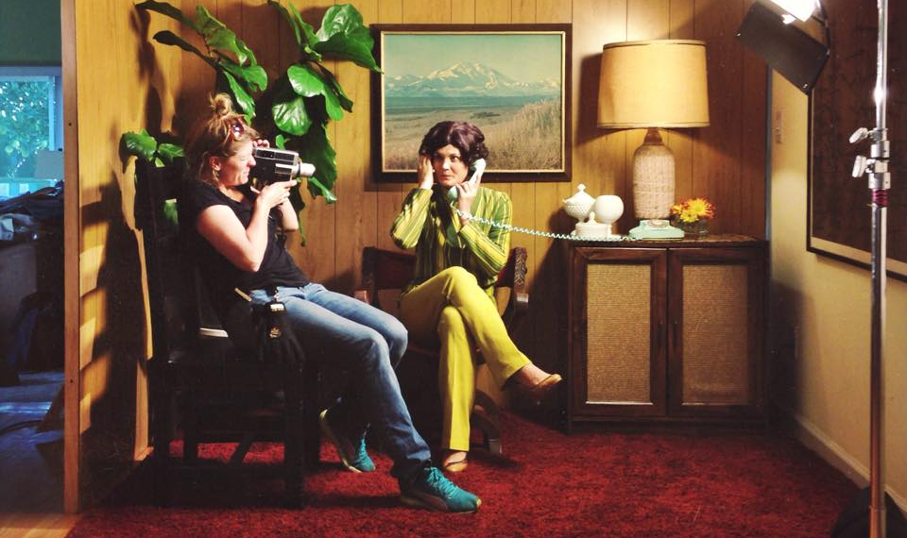

Skye Borgman filming dramatization on 8mm camera

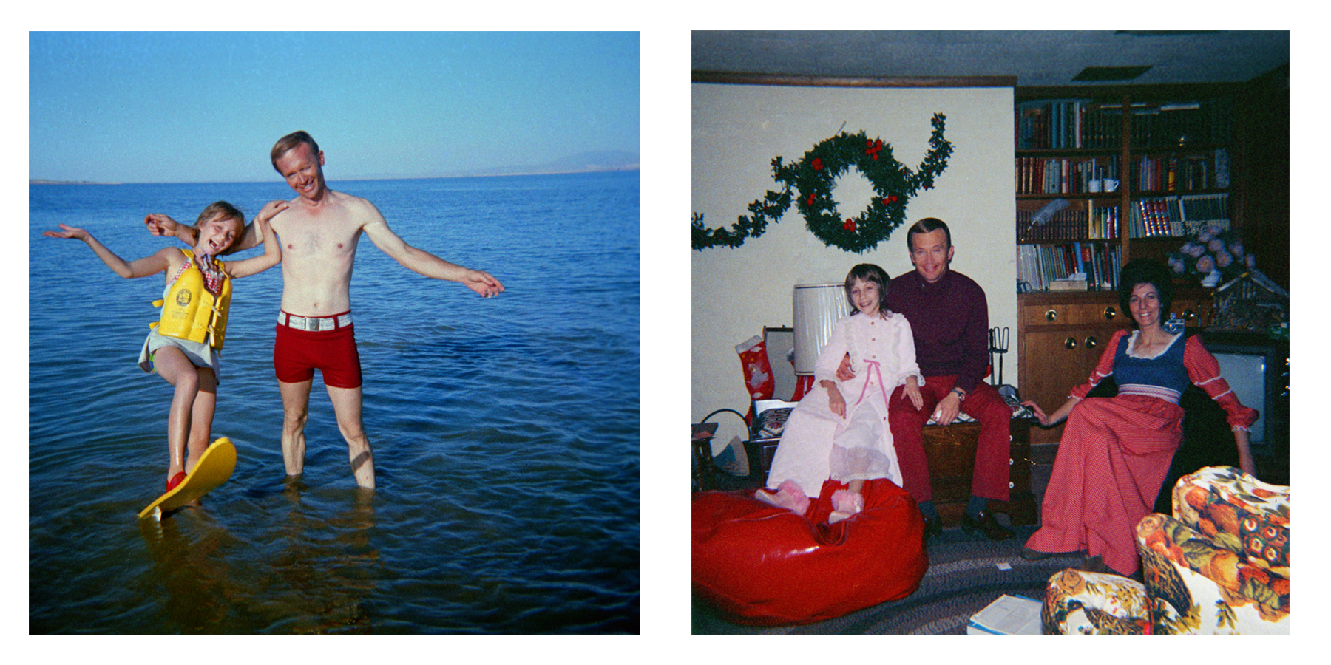
Jan and Berchtold waterskiing in 1973 Jan, ‘B’ and Mary Ann, Christmas 1973

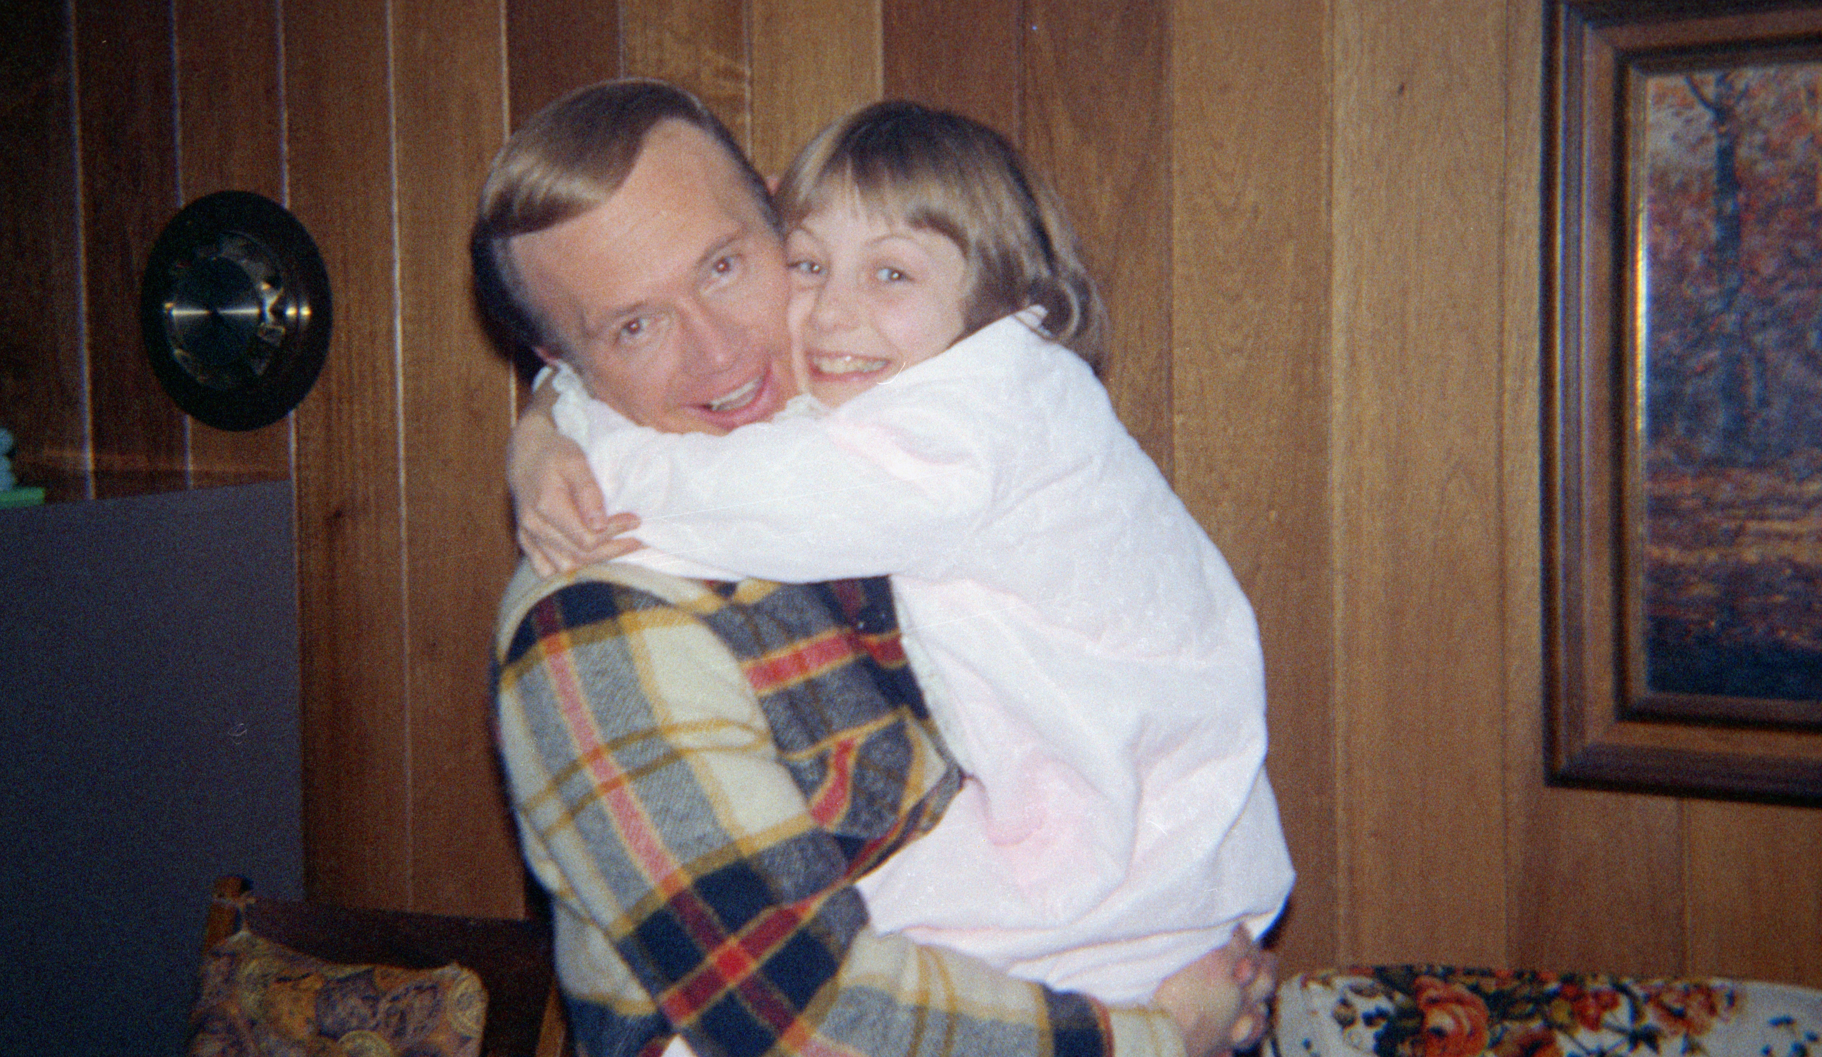

Jan and Berchtold, 1974

